**Shop Blurb**

Welcome to **Design One Online Store**. Here we have curated a range of our favourite furniture & homewares that we know will work well in your homes.

Our selections are sourced from our many suppliers around NZ and Australia. We can also help source products that may not be listed. You can email us at [office@designone.co.nz](mailto:office@designone.co.nz) if you have any product queries.

Simon James

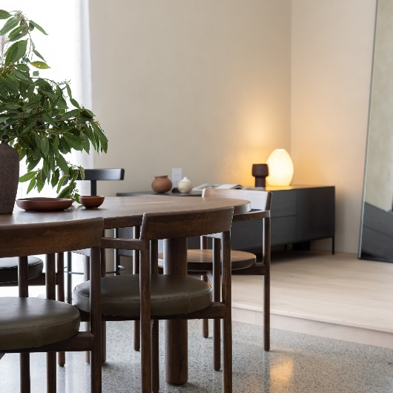 Woodwrights

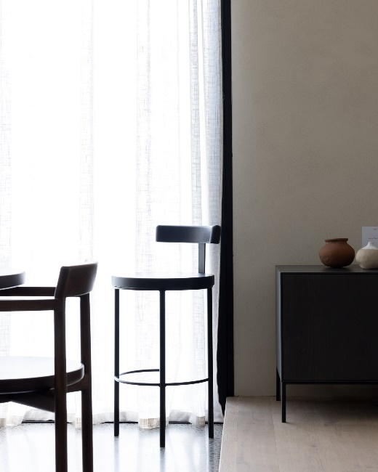 Woodwrights

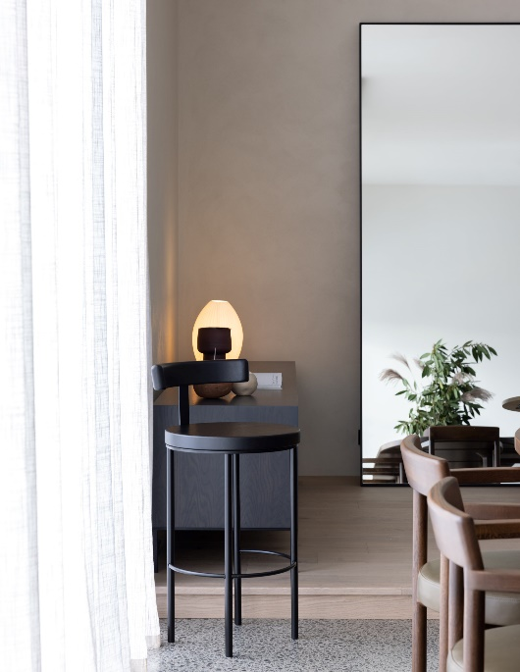 Woodwrights